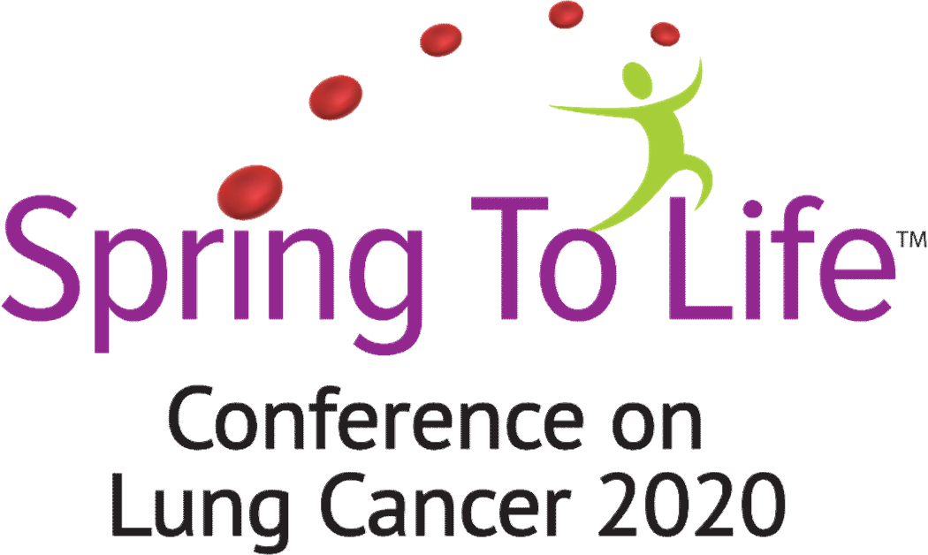

Saturday, October 10, 2020
Marriott Albany | 189 Wolf Rd, Albany, NY 12205

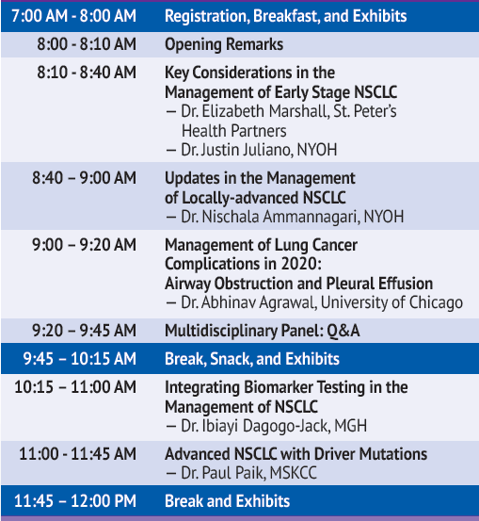

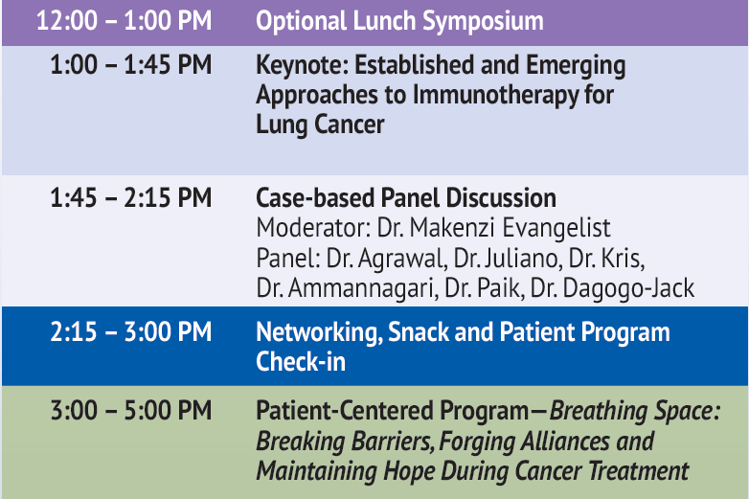

Last Updated 3/6/20
Schedule is subject to change. Visit: https://cmersvp.com/s2l-healthcare-professional/ for the latest agenda.

